ST JOSEPH’S UNIVERSITY
LANGFORD ROAD, BENGALURU-560027


Microcontroller project report on
MINI RADAR SYSTEM
Dissertation submitted for the partial fulfilment of the academic year for the award of a degree in
Bachelor of science
Electronics

Rajesh. M (21MEC04)
R. M. Lennin docras (21MEC06)

Under the guidance of
Dr. Godwin J D'souza
Head of department – Electronics

CERTIFICATE

This is to certify that RAJESH.M(21MEC04) AND R.M.LENNIN DOCRAS (21MEC06) has been working under the guidance and supervision of DR.GODWIN J D’SOUZA on this project. The Project titled as ARDUINO MINI RADAR is original and genuine research and does not form the basis of an award of any candidate for any degree or diploma in any other institution

Dr. Godwin J D’Souza (Head of the Department, Electronics)

ACKNOWLEDGEMENT

The completion of the project gives me immense happiness and satisfaction by providing me with an opportunity to express my gratitude to everyone who has played an important role in supporting me in my venture, and I would also take a step ahead to thanks everybody else who inspired my actions and work.

First of all I would like to thank Dr. Fr. Victor Lobo our principal of St Joseph’s College, for a chance that he has given us in the college for research on this project.

I would also like to express our sincere thanks to Prof. Godwin D’souza, Head of the Department of Electronics and Communications, who has always been a constant source of inspiration and enlightenment.

Lastly, I would like to express my gratefulness to my parents and friends for having shown their trust and faith in me and boosting my morals constantly I am grateful to God for his blessings which helped me to complete this project smoothly.

INDEX

Sl. No. | Contents | Page
1 | Abstract | 5
2 | Apparatus | 6
3 | Procedure | 9
4 | Conclusion | 17
5 | Bibliography | 18

ABSTRACT

ARDUINO MINI RADAR
An “Arduino radar” typically refers to a radar system created using Arduino microcontrollers and compatible sensors. In such projects, the Arduino board serves as the brain, processing data from radar sensors to detect and measure various parameters like distance, motion, or proximity. Creating a mini radar system with Arduino involves using compact components for a portable and space-efficient solution. Here’s a simplified guide:
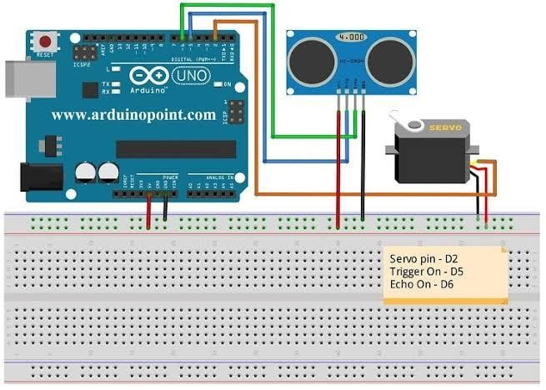

Here are some common applications:
- Obstacle Avoidance in Robotics:
Arduino radar can be employed in robotics for obstacle detection and avoidance. Robots equipped with radar sensors can navigate through environments while avoiding collisions with obstacles.
- Parking Assistance :
Arduino radar can assist in creating parking aids for vehicles. It helps drivers by detecting obstacles or measuring the distance to objects, facilitating safer parking.
- Aviation detection system:
Many VFR AND IFR radars such as beacons and other detection systems works with this ultrasonic system as they detect the reflected radio and sound waves

Apparatus :
- Arduino UNO R3 development board
- Ultrasound sensor
- Servo motor
- Breadboard
- Connecting wires
- Laptop (with Arduino and processing 3 softwares)

Arduino UNO R3 :
The Arduino UNO R3 is the perfect board to get familiar with electronics and coding. This versatile development Board is equipped with the well-known ATmega328P and the ATMega 16U2 Processor. This board will give you a great first experience within the world of Arduino. Here are some key pins:
- Digital Pins (D0-D13): Used for digital input or output.
- Analog Pins (A0-A5): Used for analog input.
- Power Pins: 5V: Supplies power, 3.3V: Provides 3.3V output, GND: Ground pins.
- PWM Pins (~): Marked with a tilde (~), these pins support Pulse Width Modulation.
- Reset Pin (RESET): Resets the microcontroller.
- TX/RX Pins: Used for serial communication.
- SPI Pins (MISO, MOSI, SCK, SS): For SPI communication.
- I2C Pins (SDA, SCL): For I2C communication.

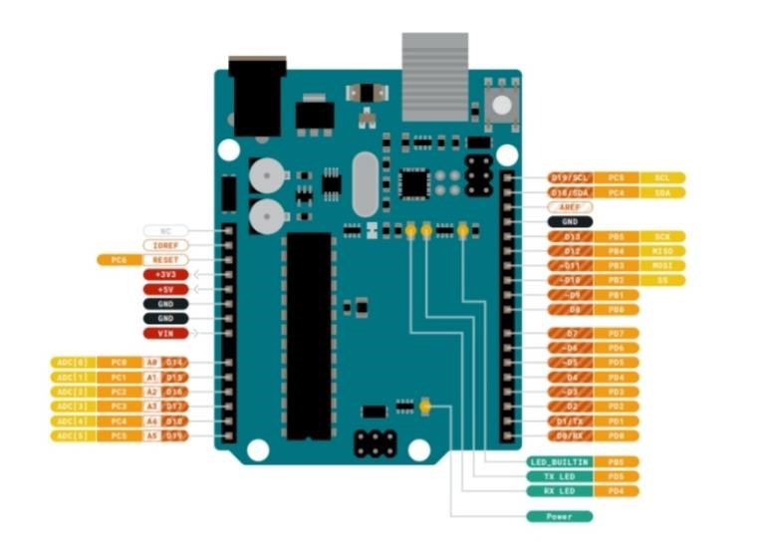

Ultrasound sensor :
Ultrasonic sensors use sound to determine the distance between the sensor and the closest object in its path. Ultrasonic sensors are sound sensors, but they operate at a frequency above human hearing. The sensor sends out a sound wave at a specific frequency. It then listens for that specific sound wave to bounce off of an object and come back. The sensor keeps track of the time between sending the sound wave and the sound wave returning
It has 4 pins : power, trigger, echo, GND

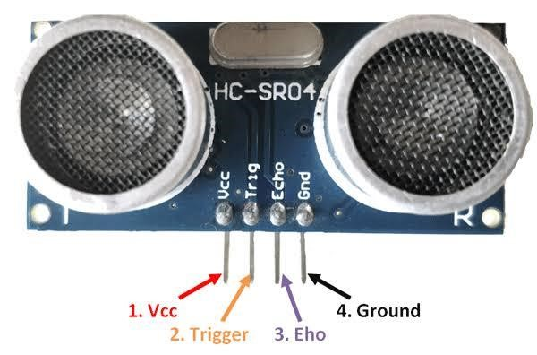

SG90 9g Micro Servo :

Tiny and lightweight with high output power. Servo can rotate approximately 180 degrees (90 in each direction), and works just like the standard kinds but smaller. You can use any servo code, hardware or library to control these servos. Good for beginners who want to make stuff move without building a motor controller with feedback & gear box, especially since it will fit in small places. It comes with a 3 horns (arms) and hardware.
3pins: power, GND and signal

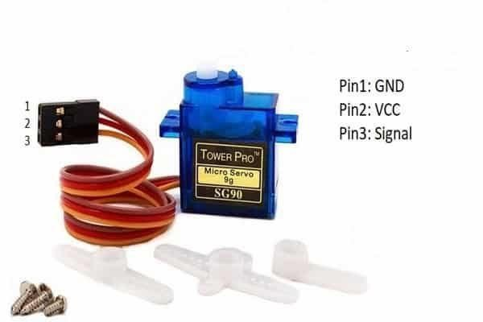

PROCEDURE :
- Get the required components for the project, I. e bring
  - Arduino UNO R3 atmel minicore atmega328p development board
  - Ultrasound sensor
  - Servo motor
  - Connecting wires
  - Bread board
- Connect the 5v power and GND in breadboard from the development board
- Connect servo to power 5v,GND , and pin 12 respectively
- Now, take ultrasound sensor and connect 5v, GND, Trigger, Echo respectively
- Trigger and echo should be connected in pin 10 and 11
- Stick ultrasound sensor on servo motor so that it’ll work like an radar turning 180 degree.
- Meanwhile make sure that your PC or laptop have downloaded the Arduino IDE latest version and processing3 softwares
- Open Arduino application and connect the development board through the USB Cable
- Ensure board is connected through Com3
- Open board manager and choose Arduino UNO. If it’s already chosen ignore this step • Type the below program and upload it in your board

Program:

// Includes the Servo library
#include <Servo.h>.
// Defines Tirg and Echo pins of the Ultrasonic Sensor
Const int trigPin = 10;
Const int echoPin = 11;
// Variables for the duration and the distance
Long duration;
Int distance;
Servo myServo; // Creates a servo object for controlling the servo motor Void setup() { pinMode(trigPin, OUTPUT); // Sets the trigPin as an Output pinMode(echoPin, INPUT); // Sets the echoPin as an Input Serial.begin(9600); myServo.attach(12); // Defines on which pin is the servo motor attached
}
Void loop() {
// rotates the servo motor from 15 to 165 degrees For(int i=15;i<=165;i++){ myServo.write(i); delay(30);
distance = calculateDistance();// Calls a function for calculating the distance measured by the Ultrasonic sensor for each degree

Serial.print(i); // Sends the current degree into the Serial Port
Serial.print(“,”); // Sends addition character right next to the previous value needed later in the Processing IDE for indexing
Serial.print(distance); // Sends the distance value into the Serial Port
Serial.print(“.”); // Sends addition character right next to the previous value needed later in the Processing IDE for indexing
}
// Repeats the previous lines from 165 to 15 degrees For(int i=165;i>15;i--){ myServo.write(i); delay(30); distance = calculateDistance();
Serial.print(i);
Serial.print(“,”);
Serial.print(distance);
Serial.print(“.”);
}
}
// Function for calculating the distance measured by the Ultrasonic sensor
Int calculateDistance(){

digitalWrite(trigPin, LOW); delayMicroseconds(2);
// Sets the trigPin on HIGH state for 10 micro seconds digitalWrite(trigPin, HIGH); delayMicroseconds(10); digitalWrite(trigPin, LOW);
duration = pulseIn(echoPin, HIGH); // Reads the echoPin, returns the sound wave travel time in microseconds distance= duration*0.034/2; return distance;
}
------------------------------------------------------------------------------------------------------------------------------
- Now Arduino software part is done
- Then it will start working
- To see the visual output you should use processing 3 software the below program

Program:
Import processing.serial.*; // imports library for serial communication
Import java.awt.event.KeyEvent; // imports library for reading the data from the serial port
Import java.io.IOException;
Serial myPort; // defines Object Serial
// defubes variables
String angle=””;
String distance=””;
String data=””;
String noObject;
Float pixsDistance;
Int iAngle, iDistance;
Int index1=0;
Int index2=0;
PFont orcFont;
Void setup() {

Size (1200, 700); // ***CHANGE THIS TO YOUR SCREEN RESOLUTION*** Smooth(); myPort = new Serial(this,”COM5”, 9600); // starts the serial communication
myPort.bufferUntil(‘.’); // reads the data from the serial port up to the character ‘.’. So actually it reads this: angle,distance.
}
Void draw() {

Fill(98,245,31);
// simulating motion blur and slow fade of the moving line noStroke();
fill(0,4);
rect(0, 0, width, height-height*0.065);

fill(98,245,31); // green color
// calls the functions for drawing the radar drawRadar(); drawLine(); drawObject(); drawText();
}
Void serialEvent (Serial myPort) { // starts reading data from the Serial Port
// reads the data from the Serial Port up to the character ‘.’ And puts it into the String variable “data”.
Data = myPort.readStringUntil(‘.’);
Data = data.substring(0,data.length()-1);

Index1 = data.indexOf(“,”); // find the character ‘,’ and puts it into the variable “index1”
Angle= data.substring(0, index1); // read the data from position “0” to position of the variable index1 or that’s the value of the angle the Arduino Board sent into the Serial Port
Distance= data.substring(index1+1, data.length()); // read the data from position “index1” to the end of the data pr that’s the value of the distance

// converts the String variables into Integer iAngle = int(angle); iDistance = int(distance);
}
Void drawRadar() { pushMatrix(); translate(width/2,height-height*0.074); // moves the starting coordinats to new location
noFill(); strokeWeight(2); stroke(98,245,31);
// draws the arc lines
Arc(0,0,(width-width*0.0625),(width-width*0.0625),PI,TWO_PI);
Arc(0,0,(width-width*0.27),(width-width*0.27),PI,TWO_PI);
Arc(0,0,(width-width*0.479),(width-width*0.479),PI,TWO_PI); Arc(0,0,(width-width*0.687),(width-width*0.687),PI,TWO_PI);
// draws the angle lines
Line(-width/2,0,width/2,0);
Line(0,0,(-width/2)*cos(radians(30)),(-width/2)*sin(radians(30)));
Line(0,0,(-width/2)*cos(radians(60)),(-width/2)*sin(radians(60)));
Line(0,0,(-width/2)*cos(radians(90)),(-width/2)*sin(radians(90)));
Line(0,0,(-width/2)*cos(radians(120)),(-width/2)*sin(radians(120))); Line(0,0,(-width/2)*cos(radians(150)),(-width/2)*sin(radians(150))); Line((-width/2)*cos(radians(30)),0,width/2,0); popMatrix();
}
Void drawObject() { pushMatrix(); translate(width/2,height-height*0.074); // moves the starting coordinats to new location strokeWeight(9); stroke(255,10,10); // red color
pixsDistance = iDistance*((height-height*0.1666)*0.025); // covers the distance from the sensor from cm to pixels
// limiting the range to 40 cms
If(iDistance<40){
// draws the object according to the angle and the distance
Line(pixsDistance*cos(radians(iAngle)),-pixsDistance*sin(radians(iAngle)),(widthwidth*0.505)*cos(radians(iAngle)),-(width-width*0.505)*sin(radians(iAngle)));
}
popMatrix();
}
Void drawLine() { pushMatrix(); strokeWeight(9); stroke(30,250,60); translate(width/2,height-height*0.074); // moves the starting coordinats to new location
line(0,0,(height-height*0.12)*cos(radians(iAngle)),-(height-height*0.12)*sin(radians(iAngle))); // draws the line according to the angle popMatrix();
}
Void drawText() { // draws the texts on the screen

pushMatrix(); if(iDistance>40) { noObject = “Out of Range”;
}
Else {
noObject = “In Range”;
}
Fill(0,0,0); noStroke(); rect(0, height-height*0.0648, width, height); fill(98,245,31); textSize(25);

text(“10cm”,width-width*0.3854,height-height*0.0833); text(“20cm”,width-width*0.281,height-height*0.0833); text(“30cm”,width-width*0.177,height-height*0.0833); text(“40cm”,width-width*0.0729,height-height*0.0833); textSize(40); text(“Indian Lifehacker “, width-width*0.875, height-height*0.0277); text(“Angle: “ + iAngle +” °”, width-width*0.48, height-height*0.0277); text(“Distance: “, width-width*0.26, height-height*0.0277); if(iDistance<40) { text(“ “ + iDistance +” cm”, width-width*0.225, height-height*0.0277);
}
textSize(25); fill(98,245,60);
translate((width-width*0.4994)+width/2*cos(radians(30)),(height-height*0.0907)width/2*sin(radians(30))); rotate(-radians(-60));
text(“30°”,0,0); resetMatrix();
translate((width-width*0.503)+width/2*cos(radians(60)),(height-height*0.0888)-
width/2*sin(radians(60))); rotate(-radians(-30)); text(“60°”,0,0); resetMatrix();
translate((width-width*0.507)+width/2*cos(radians(90)),(height-height*0.0833)width/2*sin(radians(90))); rotate(radians(0)); text(“90°”,0,0); resetMatrix();
translate(width-width*0.513+width/2*cos(radians(120)),(height-height*0.07129)width/2*sin(radians(120))); rotate(radians(-30)); text(“120°”,0,0); resetMatrix();
translate((width-width*0.5104)+width/2*cos(radians(150)),(height-height*0.0574)width/2*sin(radians(150))); rotate(radians(-60)); text(“150°”,0,0); popMatrix();
}

Now you will get the visible output of the mini radar through the monitor screen by processing 3 software.

Conclusion :

Radar systems, short for Radio Detection and Ranging, are instrumental across diverse fields due to their ability to detect and track objects using radio waves. In weather monitoring, radar systems help forecasters track precipitation patterns, severe storms, and hurricanes, providing crucial data for early warnings and disaster management.

In air traffic control, radar systems track the position, altitude, and velocity of aircraft, ensuring safe separation and efficient routing. Military applications encompass surveillance, target tracking, and missile guidance, enabling defense forces to monitor airspace and detect potential threats.

Navigation systems in ships, aircraft, and vehicles utilize radar to determine position relative to landmarks or other objects, especially in conditions of low visibility. Additionally, radar technology is employed in remote sensing applications such as ground mapping, oceanography, and environmental monitoring, providing valuable data for scientific research and resource management.

BIBLIOGRAPHY:

- Indian life hacks (YouTube)
- 8051 microcontroller- st. Joseph’s university syllabus notes
- Arduino information from Arduino website
- Processing application information from website
- Self study – the components and it’s uses (source- internet)

Radar system has been showcased in a creative way by making robot look art around it.

